Spring boot with Spring JPA Data :

Spring Data : Spring data abstract the Dao layer.

We have to make normal interface and that interface must extends JpaRepository. This JPA repository base upon Java8 default method implementation. It provided lot of pre-defined default dao layer implementation.

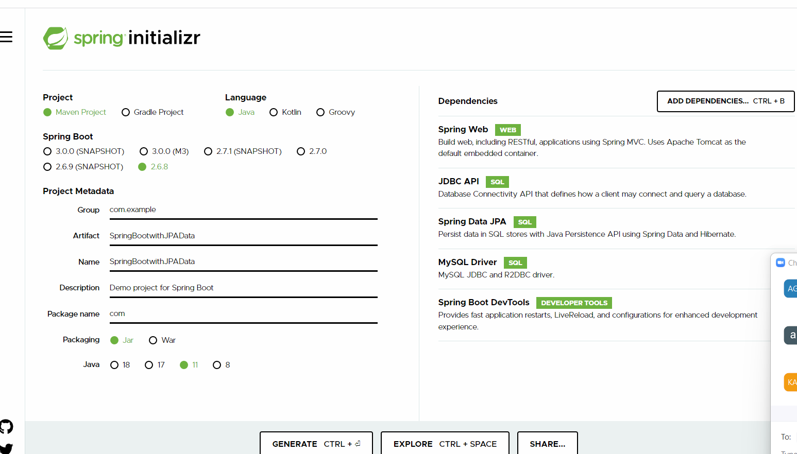

Creating the documentation for the Spring boot rest api

Swagger which help to create proper documentation for the REST API which help to rest API using gui base application

Swagger 1.x 2.x and 3.x

Open API also another tool which help to create the documentation for the REST API.

01-06-2022

So create angular project as

ng new angular-product-app

routing 🡪 yes

styling 🡪 css

ng g c product

ng g s product

ng g interface product (it can be class or interface)